Project Design Phase-II
Technology Stack (Architecture & Stack)

Date | 11 February 2026
Team ID | LTVIP2026TMIDS35897
Project Name | BookNest : where stories nestle
Maximum Marks | 4 Marks

Technical Architecture:
The Deliverable shall include the architectural diagram as below and the information as per the table1 & table 2
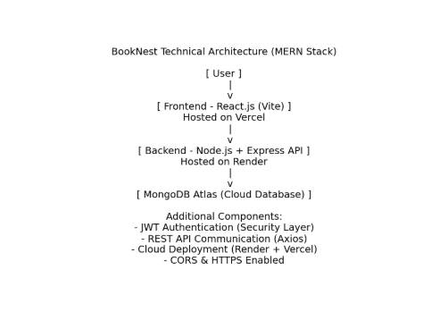

External APIs

Guidelines:
UI Layer:
React.js (Vite) web application for user registration, login, book browsing, cart management, and order placement. Hosted on Vercel.
Backend Layer:
Node.js + Express REST API handling authentication (JWT), book management, cart operations, and order processing. Hosted on Render.
Database:
Cloud-based MongoDB Atlas (NoSQL) storing users, books, and orders.
API Communication:
Frontend communicates with backend using Axios and REST APIs (JSON format).
Security:
JWT authentication, bcrypt password encryption, HTTPS enabled, and CORS configuration.
Scalability & Deployment:
Cloud deployment with independent frontend and backend scaling using Vercel + Render + MongoDB Atlas.

Table-1 : Components & Technologies:
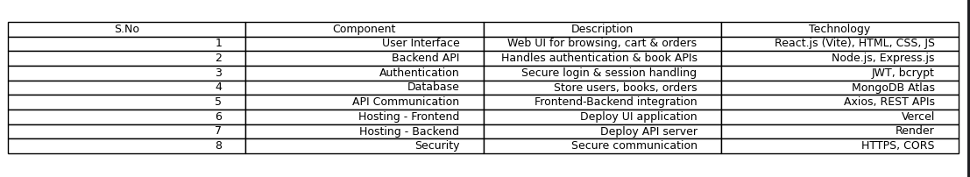
Table-2: Application Characteristics:
